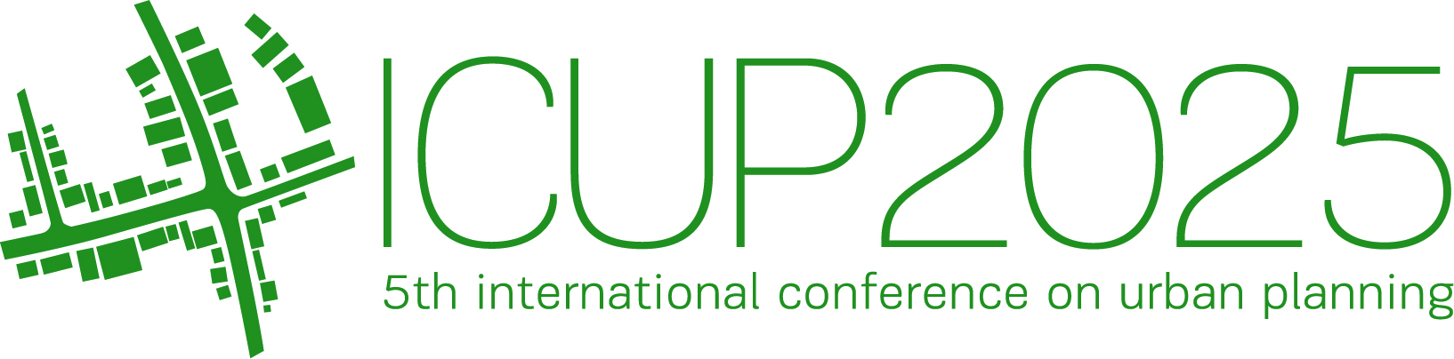
paper Preparation guidelines
FOR ICUP 2025
John Smith
Affiliations, Country
PhD., Associate Professor, johnsmith@yahoo.com
Jane Doe
Affiliations, Country
PhD., Full Professor, janedoe@gmail.com
ABSTRACT (Style of the paragraph: ‘<abstract’; 10pt, Bold, italic)
These Preparation Guidelines aim to give to potential participants the necessary information relevant for the Papers submission to the 5th International Conference ‘ICUP 2025’. These Guidelines ought to be respected so that each Paper submitted has a consistent appearance. This document itself is formatted according to the required Formatting-styles (names consist of symbol ‘<’). Since it is supplied as a Microsoft Word file, it can be used as a proper template. We, therefor, strongly suggest Authors to replace the content of this file with their own (preserving the existent page-setup/formatting and no adding any extra line-spaces i.e. blank rows, except in the case of usage ‘Page-breaking Rules’). To facilitate and simplify the formatting of paper, it is also possible to paste the complete content from another source/document, and then format it by simple selecting the titles, text, captions, etc., and then clicking the appropriate Style from the Styles gallery, at the Home tab (top ribbon). The length of the abstract is limited to 250 words.
Keywords: urban planning; international conference; preparation guidelines; paper formatting; general information

1. General Information
Two versions of the Conference Proceedings will be provided:
- an electronic version (‘The Electronic Proceedings’), and
- a printed version (‘The Proceedings’).
Both electronic proceedings and printed proceedings will consist of all accepted Papers (in full).
The Paper has to be written in English only. Submitted documents will be reviewed prior to the final acceptance. The Paper will be published only if it is accepted. The Paper should be structured so as to gain: a description of the problem investigated, an application field that the problem belongs to, research stages performed, methods used, results obtained, conclusions formulated, description of other research planned/needed, and the listing of all references cited.
The formatting styles that should be applied on the Paper are the same as in this document.

2. paper length and its constituents
The body text of the Paper should start with an introduction, followed by the main body of text, and completed with conclusions, followed by a list of references. But, if appropriate, the Paper should be finalized with Acknowledgements and Notes on contributor(s) (if any). A Paper with no appendices is required. Footnotes should be placed at the bottom of the page of their first mention.
The structure of the main body of the Paper is up to the Author(s), and it should be logically defined respecting the already pointed-out section-hierarchy in general and sized so that the total number of pages does not exceed 8 (including all footnotes, figures, tables, references, acknowledgement(s) (if any) and notes on contributor(s)). The first (Title-page) will be right-sided (i.e. even).

2.1. Figures
The Image-layout (including necessary Caption-content) must be identical to that in the example below and scaled properly. Each Figure should be centred.
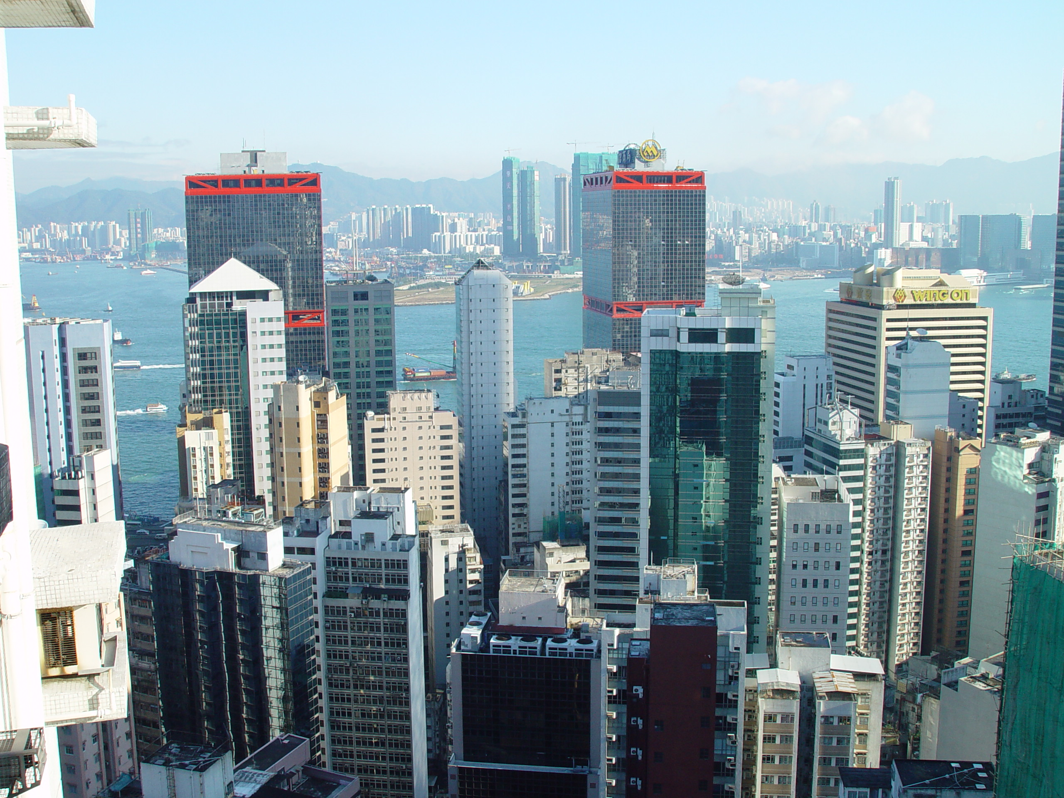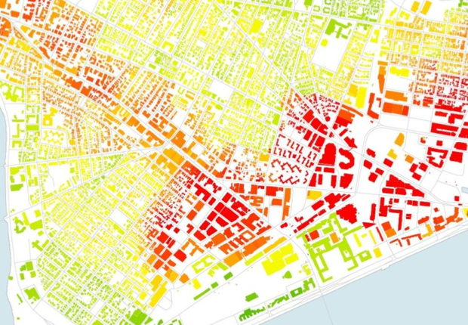
(a) (b)
Figure 1: (a) Image, and (b) Plan
Images/photos embedded have to be in one of the following formats: JPG, TIFF and PNG (minimum of 300 dpi should be used).

2.2. Tables
The table layout must be identical to that in the example below. Each Table should be centred. Tables must not be in the form of spread-sheets but Word created.
Table 1: Table title
Table | A | B | C | D | E | F | G
Full site | 99.96 | 0.320 | 0.154 | 16.7 | 40.9 | 31.6 | 10 B 8
Sub-scene | 98.32 | 0.310 | 0.165 | 25.7 | 27.9 | 35.2 | 11 B 2
(Table-filling Style: ‘<Table filling’; Style of the following paragraph (if any): ‘<First paragraph’; No empty lines before and after the table)

2.3. Mathematics
To respect proper mathematical conventions as well as to minimise the Author’s effort including that on the part of the copyeditors, the usage of Math-Editor is suggested. Each equation should be left-positioned while its naming should be right-positioned (as follows):
( Eq.1)
$v=L^{−1}{\left({\text{BLB}}^{T}\right)}^{−1}\text{Ax}+w$ ( Eq.2)
(Style of the following paragraph (if any): ‘<New paragraph’)

2.4. Displayed Quotations
‘Displayed quotations ought to be indicated by ‘single’ quotation marks (‘) and positioned in the text where it is necessary. Only ‘longer’ quotations (with more then 40 words) must be located separately, indented and formatted in this way’.

2.5. Page-breaking Rules
There must not be empty/blank rows between consecutive single- and multi-line sections, except in the case of respecting following ‘Page-breaking rules’ that Author(s) has to apply in the final text-processing pass.
Those ‘Page-breaking rules’ are:
- No headings of any level must be located at the bottom of a page - without a minimum of 2 ending rows of subsequent text: if else, the headings must be pushed up to the very top of the next page,
- In case of enumeration, at least one numbered (or bulleted) item should be placed immediately after the introductory sentence at the same page. If it is not possible, the introductory sentence should be moved to the beginning of the following page,
- The total number of pages should be even.

Acknowledgements (Style of the paragraph: ‘<heading1’)
Only sources of project funding (if any) should be acknowledged. Such acknowledgements should be located at the end of the body text of the Paper.

References
Unpublished results and inter-personal communication are not recommended in the reference list, but may be mentioned in the text (if these references are included in the reference list they should follow the reference style shown below – including a substitution of the publication date with one of the following notes: either with ‘Unpublished results’ or with ‘Personal communication’. Citation of a reference as ‘in press’, implies the fact that ‘it has already been accepted for publication’).
The reference list should be alphabetically ordered (by the surname of the first Author) and formatted (by using its own style: ‘References’). That list must have at least 2 relevant items.
According to a concrete type of reference item, there are several possibilities:
1. Smith, J. J. and Doe, J. J., 2015. Article title. Journal name, 15(88). pp 545–560.
2. Smith, J. J., 2011. Book Title. Second edition. McGraw-Hill, New York, USA.
3. Smith, J. J., 2010. Chapter title. Chapter 7 in Publication Name (Eds. A. A. Anderson, B. B. Bridgens and C. C. Conte). Wiley, Chichester. pp 139–164.
5. Smith, J.J. and Doe, J. J., 2016. Conference paper title. Proceedings of Conference name, Belgrade, Serbia. pp. 281–305.
6. AAAA, 2008. http://www.site.com/rethink/1.htm [Accessed: 1st December 2009].

Generally, a text of the Paper has to be prepared by Microsoft Word processor, using A4 (210 mm x 297 mm) single-column pages. The effective working area of each page is defined by the margins: Top - 2.5 cm, Bottom - 2.0 cm, Left – 2.0 cm, Right – 2.0 cm (Gutter - 1 cm, Left). Header and footer positions from relevant edges of the A4 paper are: 2.0 cm and 1.0 cm. The default Tab-stop should be set to 0.75 cm. All text should be typed in Calibri font and mainly be fully justified (that is on both left and right sides). The main text uses 10 pt. (including the Abstract and the Reference list), Article Title uses 14 pt. font, while footnotes, figure/table captions (labels) and longer quotations are in 8 pt. font. Single quotation-mark (‘) is allowed only.

